Graven imbues a spirit of conviviality in new Chivas Brothers HQ in Glasgow

For immediate release

International design studio Graven, has designed new, award-winning offices for Chivas Brothers, the Scotch whisky business of Pernod Ricard, on Blythswood Square in Glasgow’s city centre.

Relocating Chivas Brothers’ Scotland headquarters from their historic location in Paisley, this project allowed Graven to combine their wealth of experience designing hospitality environments and luxury brands with their award-winning expertise in workplace design.

The design brief demanded a complete reimagining of the work environment. Graven’s approach puts Chivas Brothers at its heart and truly embodies Pernod Ricard’s vision statement, "Créateurs de Convivialité" (creators of conviviality).

Graven prioritised an exceptional and flexible working environment to support the organisation’s future plans, effectively combining architecture and technology to enable staff to get the best out of all areas of the building depending on their task or needs.

Graven is among the top office design firms in the UK, having been awarded the coveted British Council for Offices (BCO) Best Fit Out of Workplace, Scotland award 2020.

Juliette Legros, project lead and Business Analysis Manager at Pernod Ricard said:

“The Chivas Brothers Glasgow office move in September 2019 was an important part of a broader company-wide transformational journey. We had big ambitions for uniting our people, improving the interconnectivity of our teams, moving to more agile, flexible ways of working, as well as improving the wellbeing of our people - achieving the BCO award is testament to the project teams’ success in achieving that ambition.”

Kirsty Lang, Director at Graven said:

“It’s been a pleasure for Graven to work with the Chivas Brothers team. We’re proud of our design and grateful to work with such a forward-thinking and ambitious client. We’re especially pleased that international groups such as Pernod Ricard are selecting Glasgow city centre as their new home.
We’re equally happy that our flexible design and technology can support new ways of working emerging since, and during the pandemic, and recognise that excellent quality and fully experiential offices are more relevant than ever to support and attract our teams back to the workplace. It’s been a challenging time for many working from home, but also a great opportunity for organisations to be similarly ambitious and rethink how they wish to work going forwards. Graven is supporting many of our clients to plan and achieve both a safe and exciting transition back to their workplaces.”
Graven’s design draws together many contrasting elements into a coherent, flowing work environment. A notable design feature is the bespoke ‘wonder wall’ which celebrates the Chivas Brothers core brands and acts as a backdrop for the Lounge. The wall incorporates products and images illustrating carefully curated interactions of people, brands and experiences.

Innovation and creativity are at the core of workplace design for Graven. The studio utilised BIM software - a digital design tool for architects and designers – developing the proposals in 3-dimensions throughout the design process.

Social spaces are paramount. This included the design and build of a ‘convivial lounge’, coffee bar, technologically enabled meeting rooms, and a super-flexible kitchen. There is a fully equipped bar where, as well as occasional relaxation, the team and its business partners can train and develop their skills and knowledge.

State-of-the-art meeting spaces supported by a range of technology solutions have been designed to give the team every chance to be as collaborative as possible in their new environment, both locally and with their international team and partners and more recently, home workers.

Flexibility is key as businesses adapt to blended work environments, and when Covid-19 restrictions allow, people can and do work between home and office. A recent British Council for Offices (BCO) survey revealed that workers will adopt a mixed approach once the Covid-19 crisis is over. Seven out of 10 workers the BCO surveyed said the office was important for learning and developing networks.

Graven’s experience in the hospitality industry helped introduce a level of quality, comfort and luxury that not many workplaces can enjoy. Graven’s previous success in creating innovative workplaces includes working with major organisations such as Royal Bank of Scotland (OX), BBC Scotland and BCO National award-winning Registers of Scotland. Graven was also responsible for the recently refurbished designs for the luxury Kimpton Blythswood Square Hotel

ENDS

Enquiries / interviews / further images:
Meadhbh Hendrie, for Graven
T: +44 (0)141 548 5191 / 44 (0)7889 178 941
E: meadhbh@sprengthomson.com

Photography: © Renzo Mazzolini Photography
Notes to Editors

About Graven
With over 30 years of experience, multi-award-winning design studio, Graven, helps to build some of the world’s biggest brands.

Graven was one of the first UK design studios to strategically integrate brand-thinking and communications into the design of environments and places. Today they are industry-leading experts creating successful visual and environmental brands across retail, leisure, corporate and public sectors including Banking & Finance, Hotels & Leisure, Education & Health, Luxury Goods and Competitive Place.

Using their bespoke trademarked process Graven models brands to meet the needs of both boardrooms and customers, improving relationships and optimising performance. They help plan the evolution of brands and businesses and deliver their operational environments—including their visual brands and trademarks, communications and experiences, products, processes and services.

Connect with Graven:

http://graven.co.uk/
https://www.linkedin.com/company/graven/
https://www.instagram.com/graven_hq/
https://twitter.com/GravenHQ

Selected images: higher resolution images are available on request

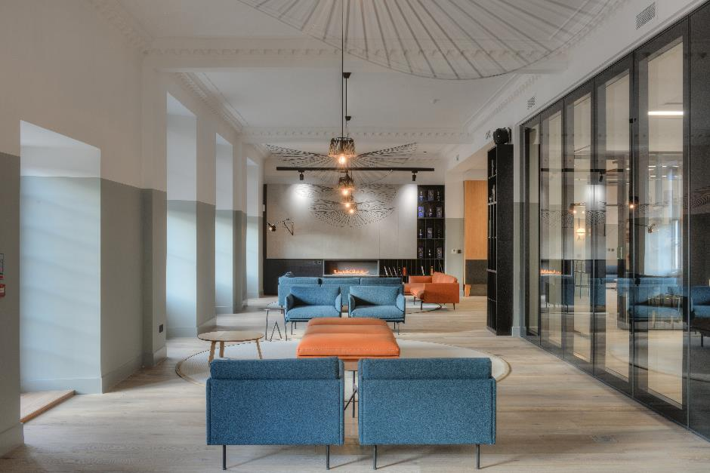
Convivial Lounge.

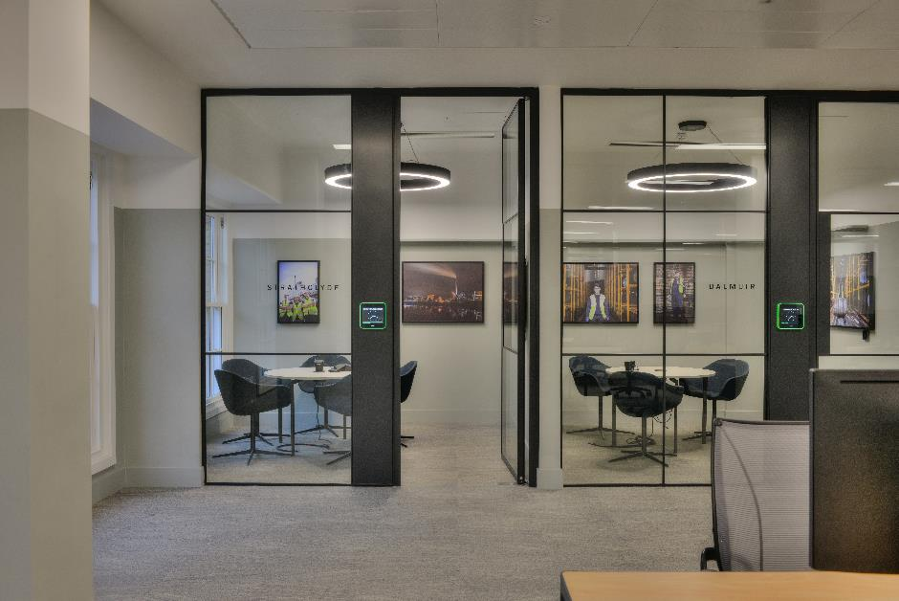
First floor meeting rooms.
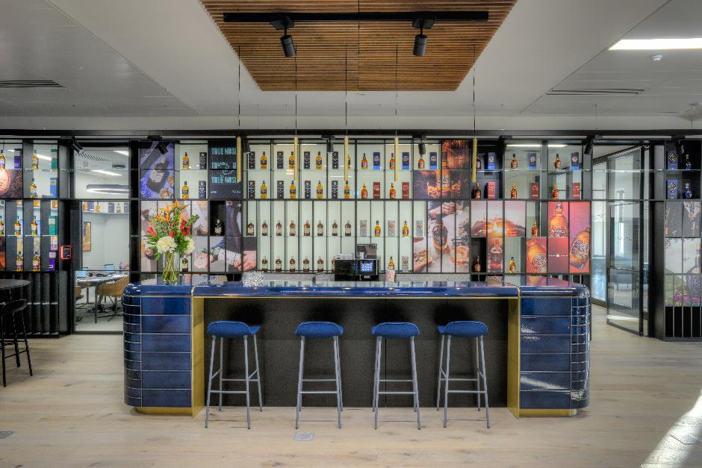
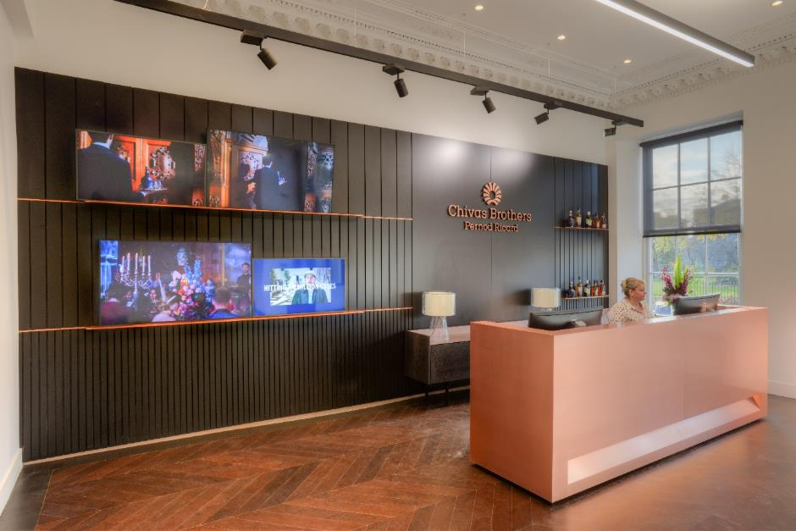
Coffee Bar (situated within the Convivial Lounge).

Reception

