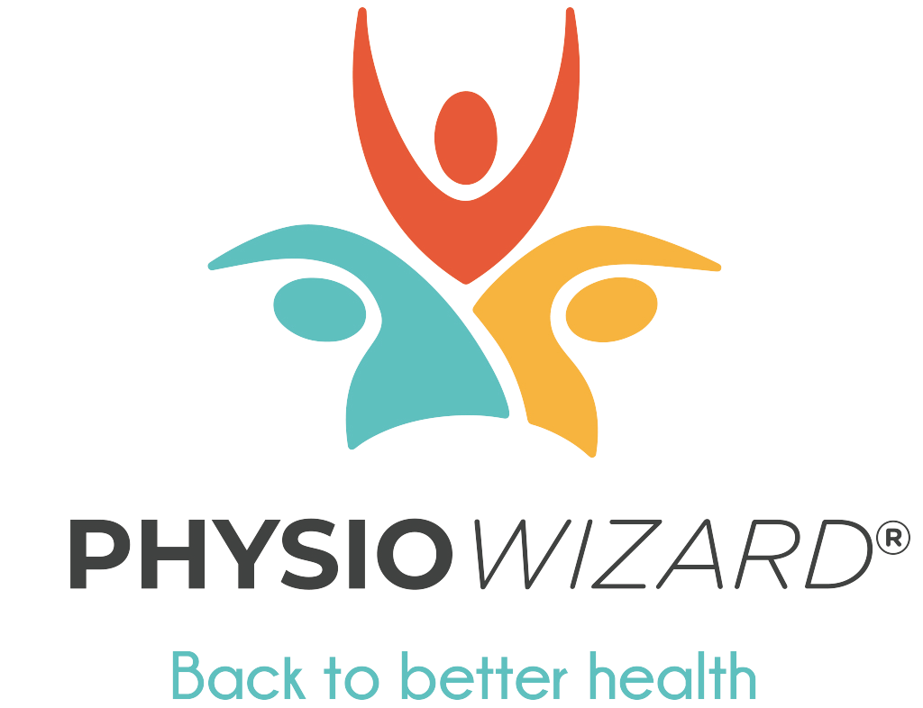
PRESS RELEASE
PHYSIO TECH COMPANY STEPS IN TO TACKLE
COVID-19 LOCKDOWN NECK AND BACK PAIN EMERGENCY

Millions of workers operating from home could be creating a backlog of neck and back pain complaints which the NHS will struggle to cope with. Now physiotherapy experts at PhysioWizard®, the UK’s first clinically validated digital triage service for muscle and joint problems, are so concerned that they have stepped in to offer their online self-assessment tool direct to the public and free of charge.

Since the introduction of the Coronavirus lockdown, the proportion of people working from home has risen to 38%*, with many developing muscle and joint problems caused by a combination of factors – poor working postures, physical deconditioning from lockdown and the increase in stress and mental health issues, commonly linked to persistent symptoms and chronic pain. Whilst medical services have been diverted to COVID-19 related issues, those with muscle and joint problems are adding to the treatment backlog now that full-time services are restarting.

With back pain complaints already one of the largest single causes of GP visits prior to lockdown, this build-up is set to create significant pressure on NHS clinicians and services as they return to normal.

Neck and back pain sufferers can log on to the PhysioWizard online self-assessment tool here: www.physiowizard.com/free-assessment where they can undertake a 10-minute self-assessment which has been proven to replicate a physiotherapist’s assessment with 93% clinical accuracy. PhysioWizard is being supported with a grant from Innovate UK, the UK Government’s innovation agency, to enable the further development of the service.

PhysioWizard accurately matches the patient with the recommended treatment (triage), and the platform promotes patient-led care, enabling users to actively participate in their treatment and achieve better results.

Many of the UK’s office workers are currently operating from home, often sitting at kitchen tables, on couches or even perched on the sides of their beds. People are often unaware of the relationship between poor posture and pain, and don’t realise that simple advice and exercises can have a significant benefit on those who are waiting to see a healthcare professional.

PhysioWizard, which is headquartered in Edinburgh, was founded by Kirsten Lord, a Chartered Physiotherapist with 30 years’ experience of treating thousands of patients, working with a team of specialist physiotherapists.

Kirsten said: “I founded this company to give people with pain, disability or fear easy access to simple and effective information, so helping people with back and neck pain caused by working from home and accelerating their recovery, is core to our mission. Delivering healthcare using digital tools will help manage the risks associated with community transmission. There is no better time to use technology to care for people than now. Every person that receives an assessment with PhysioWizard is one less appointment in the NHS. This will help to manage people quickly and prevent a backlog from building up.”

The importance of sound ergonomics around office desk seating arrangements have long been recognised as vital to ensuring that workers enjoy a safe and injury-free working environment. However, the sudden lockdown, with millions of workers sent home, has resulted in many totally unsuitable arrangements having been adopted.

After many years of R&D and clinical validation trials, PhysioWizard is the only clinically validated self-assessment tool for muscle and joint problems that patients complete online. The platform is currently used in occupational health and is sold to healthcare providers who in turn, make the service available to the employees of companies, to help manage conditions and seek appropriate help. The assessment gives information on what to do next, whether that’s referral to healthcare professionals or services, or advice and exercises.

Andrew Byers joined PhysioWizard as Chief Executive earlier this year. He and Kirsten work together closely. He said: “We are all working in a new way with a considerable amount of time now spent on video conference calls. Finding quiet places to work has seen people using sofas, kitchen tables and edges of beds. We’ve seen footage of someone sitting on a toilet seat balancing a laptop on their knee while on a video call because it was the only room free in the house!

“This is a neck and back pain emergency and our mission is to get help for sufferers; to speed up response times; and to reduce the strain on scarce NHS resources. We normally provide our service to large occupational health companies for a fee but because of the pressures created by COVID-19 we believe it’s the right thing to make our online solution available, free of charge for a three month period, direct to the general public. We have also been contacted by concerned organisations and employers and we are happy to extend this offer to their staff members and associates. Addressing underlying problems will be key in sustaining the current remote work environment and our return to the new normal.”

Lower back pain alone is the biggest cause of ill health in the world and places a considerable burden on healthcare resources worldwide.

- Back pain causes of 12.5% of employee absenteeism
- Lower back pain is one of the main causes of time off work
- Lower back pain typically results in 19 days off work
- 14% of all GP appointments are attributed to treating back pain
- Back pain is estimated to cost the UK economy £17bn per year

The PhysioWizard team’s fear is that many sufferers will have resisted seeking help for muscle and joint pain during the COVID-19 lockdown due to limited and stretched GP services, physiotherapists being unavailable or a reluctance to visit hospitals for fear of infection.

The service is being provided free of charge direct to the public, employers and healthcare professionals for three months from today, Monday 20th July. PhysioWizard receives no revenue from referrals or any other charges to patients.

PhysioWizard is backed by leading Scottish business angel syndicate, Archangels, and by BioCity.

Ends 20th July, 2020

* Source: YouGov Daily Coronavirus Tracker 8-11 May, 2020

FURTHER ENQUIRIES:

Callum Spreng Tel: 07803 970103
Spreng Thomson Email: callum@sprengthomson.com

ABOUT PHYSIOWIZARD:
PhysioWizard is an online platform & mobile application that enables people to assess their muscle & joint problems online. The software recommends the most appropriate healthcare professional, service and/or self-help options, and produces detailed patient & clinical reports with advice and steps on what to do next which can be accessed via portals by patients and therapists.

The PhysioWizard platform helps to maintain social distancing to reduce community transition whilst providing reliable advice and information to those experiencing muscle or joint problems.

